**Unit 14 I remember meeting all of you in Grade 7.**

**Section B3 (3a-Self check)**

**【学习目标】**

1．识记本单元的重点单词及短语：survey, standard, row, keyboard, method, instruction, double, shall, overcome, caring, ours, senior, text, level, degree, manager, gentleman, congratulate, thirsty, thankful, task, ahead, separate, wing, in a row, look back at, make a mess, keep one’s cool, senior high(school), go by, first of all, be thirsty for, be thankful to sb., ahead of, along with, be responsible for, set out, separate from并能熟练应用。

2．熟练掌握现在完成时的用法，能准确应用于写作等练习中，并能够较为准确的介绍自己三年的初中学习情况。

**【重点和难点】**

1．培养乐善好施的良好品质，做一名义务志愿者。

2．要勇于挑战自己，完善自己的意识。

3．复习谈论你过去是什么样子或你过去常常做什么。

4．复习使用used to do sth.

**【课前预习】**

**一、翻译短语。**

1. 对某人心存感激____
2. 连同____
3. 对......有责任____
4. 渴求，渴望____
5. （时间）过去____
6. 弄得一团乱____
7. 沉住气；保持冷静____
8. 骄傲____
9. 出发；启程____
10. 犯错____
11. 放弃____
12. 在......之前____
13. 充满…... ____
14. 处理____
15. 成长____
16. 学校调查____
17. 连续几次地____
18. 达标____
19. 休息____
20. 清楚地指示____
21. 对某人有耐心的____
22. 解决____
23. 指导某人做事____
24. 投入更多的努力____

**二、阅读111-112页的句子，翻译句子。**

1. 我不敢相信今天是初中的最后一天。

________________________________________

2. 虽然我很难过初中毕业了，但我期待高中的新经历！

________________________________________

**【合作探究】**

**探究一、**Collect words，phrases and sentences.

1．I can write. (我会写)

翻译下列短语：

1) 初中最后的一天____

2) 恐惧和紧张____

3) 分享如此多的美好的记忆____

4) 自从那时起____

2．I can translate. (我会译)

1) 自那以后，我交了如此多的好朋友，并和他们分享了如此多美好回忆。

____ ____, I ____ ____ so many good friends and ____ so many good memories with them.

2) 我记得七年级的第一天就像昨日一样。

I still remember ____ ____ ____ of Grade 7 like ____ ____ ____．

3) 要和那些近三年来一起度过如此多时间的朋友们分别真的很难。

It is always hard to ____ ____ those friends whom you have spent so much time ____ for the past three years.

**探究二、**

【单元写作目标】

本单元的话题是“school days (学校生活)”，以回忆自己或他人的学校生活为主线，以感恩为主题，主要描写人物或记叙事件。这类文章通常是提示性作文，同时又兼有开放性。此类话题源于实际生活，注意从平时的生活中提炼素材并写出自己的所感所想。

单元写作素材

(一) 单元话题短语积累

1．展望；为(将来)设想____

2．回首(往事)；回忆；回顾____

3．高中____

4．对某人要求严格____.

5．在某人的帮助下____

(二) 单元话题句子积累

6．在他的帮助下，我取得了巨大的进步。

____ ____ _____, I've made great progress.

7．我必须感谢王老师。

I must ____ ____ ____ Mr. Wang.

8．我即将从初中毕业。

I'll ____ ____ my junior high school.

9．我的初中生活是一次难忘的经历。

My junior high school life is ____ ____ ____．

话题范文剖析

每个人的一生中都会有令自己难以忘记的人。回想一下自己的成长过程，对你影响最深的老师是谁？请你根据以下要点提示，以“The Nicest Teacher in My Heart”为题，写一篇英语短文。

|  |  |
| --- | --- |
| Subject | Chinese/math/English… |
| Appearance(外貌) | tall/short/of medium height/heavy/thin/…  ordinary－looking(相貌平常的)/beautiful/handsome… |
| Personality(性格) | friendly/kind/popular/love to smile… |
| Reasons(原因) | do a good job/be strict with/be like a mother/father/encourage me to… |
| 其他 | … |

注意：

1．文中请勿使用真实人名、校名和地名；

2．内容可参考表格中的要点并适当发挥；

3．词数：80词左右；

4．文章的开头已给出，但不计入总数。

◆◆审题指导

1．文体：记叙文

2．时态：谈论老师的情况以及自己喜欢的原因可使用一般现在时；谈论老师对自己的帮助应使用一般过去时

3．注意事项：谈论老师应该采用第三人称，谈论自己的感受应该使用第一人称。

◆◆思路点拨

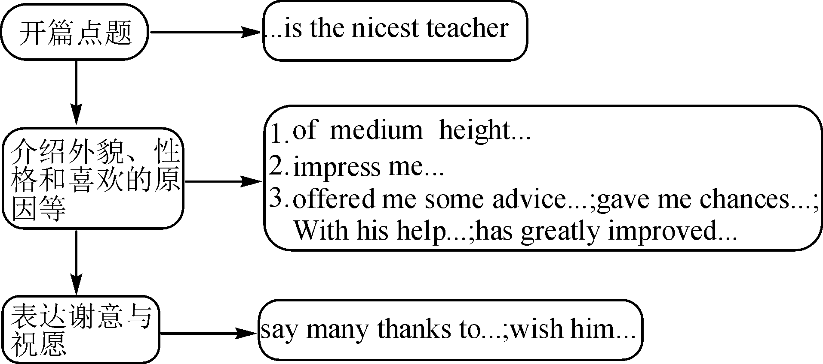

◆◆范文欣赏

**The Nicest Teacher in My Heart**

Junior high school days will be over，I have some special memories. One of them is about a teacher. In my heart，Mr. Wang，my English teacher，is the nicest teacher.

He is **of medium height.** We think he is very handsome. He **impresses me with** a friendly，kind and hard－working teacher. He **is strict with** us in English. He helps us with English not only in class but also after class. About two years ago, Mr. Wang noticed that I was worried about my poor pronunciation. So he **offered me some advice** and **encouraged me to improve** it. He also gave me chances to speak **as much as possible** in class. **With his help**, my pronunciation has greatly improved.

I must say many thanks to Mr. Wang. I wish him a healthy and happy life in the future.

单元写作练笔

你的初中生活即将结束。此时此刻，正是回顾过去，展望未来之际。请写一篇英语短文，谈谈你对初中三年学习生活的感受和对高中生活的向往。短文需包括如下要点，可适当拓展以使行文连贯：

1．师生关系；2. 学业成就；3. 生活乐趣；

4. 感受初中；5. 向往高中。

注意：

1. 文章的开头结尾已给出，不计入总词数；

2. 词数：80左右。

_______________________________________________________________________________________________________________________________________________________________________________________________________________

**【课时小结】**

重点词组

1. the last day of junior high school 在初中的最后一天

2. scared and nervous 恐惧和紧张

3. share so many good memories 分享如此多美好的记忆

重点句式

1. I still remember the first day of Grade 7 like it was yesterday.我仍然记得七年级的第一天，就像是昨天一样。

2. I thought I would never make any friends.

我原以为我会永远交不到任何朋友。

3. Even though I am sad that junior high is over, I look forward to new experiences in senior high!

虽然我难过初中生活结束了，但我期待高中的新生活。

**【达标检测】**

**一、用所给词的适当形式填空。**

1. I used to __________ (be) a shy girl.

2. I __________ (make) so many friends since I came to China.

3. Now I realized that I was just _________ (be) silly at that time.

4. I can’t ___________ (believe) that time went by so fast!

5. I am looking forward to ___________ (get) into a senior high school now.

**二、根据所给汉语完成英语句子。**

1. 我不敢相信今天是初中学业的最后一天。

I _________ _________ that today is the last day of junior high school.

2. 我仍然记得七年级的第一天就像是昨天。

I still remember the first day of Grade 7 like _________ _________ yesterday.

3. 我过去是一个害羞的人，我感到害怕和焦躁不安。

I used to be a really _________ _________, I was so _________ and _________.

4. 从那以后，我和朋友一起分享了这么多美好回忆。

Since then, I have shared so many ________ _________ _________ my friends.

5. 尽管我对初中结束感到难过，我期望着高中新的经历。

Even though I am sad that junior ________ _________, I am ________ _________ _________ new experiences in senior high!

**三、单项选择。**

1. You always ______ a mess. I can’t stand you any longer.

A. set B. give C. make D. take

2. They are going to London next month. They are _____ visiting the Buckingham Palace.

A. looking at B. looking for

C. looking forward to D. looking over

3. We all want to know who can ______ the physics problem. You know, it’s very difficult.

A. work out B. take out C. set out D. look out

4. Mark works hard now, and he does his work ________ than before.

A. more careful B. more carefully

C. most careful D. carefully

5. Mr. Smith, a famous scientist, _______ that park next Thursday.

A. visits B. visited C. will visit D. was visiting

**【自我评价】**

1. 本课我学会了什么？

___________________________________________________

2. 通过本课的学习，我还有哪些疑问？

___________________________________________________

**参考答案：**

【课前预习】

1. be thankful to sb.
2. along with
3. be responsible for
4. be thirsty for
5. go by
6. make a mess
7. keep one's cool
8. be proud of
9. set out
10. make mistakes
11. give up
12. ahead of
13. be full of
14. deal with
15. grow up
16. school survey
17. in a row
18. meet the standard
19. take a break
20. clear instructions
21. be patient with sb.
22. work out
23. guide sb. to do
24. put in more effort

翻译句子。

1. I can’t believe (believe) that today is the last day of junior high school.

2. Even though I am sad that junior high is over，I look forward to new experiences in senior high!

探究一

1. the last day of junior high school
2. scared and nervous
3. share so many good memories
4. since then

2.

1) Since then; have made; shared

2) the first day; it was yesterday

3) separate from ;with

探究二

(一)

1. looking forward to
2. look back at
3. senior high school
4. be strict with sb.
5. with one's help

(二)

1. With his help
2. say thanks to
3. graduate from
4. an unforgettable experience

单元写作练笔

I'll graduate from my junior school. At the moment of looking back at the three years and looking forward to the senior high school, many words have come to my mind.

The first to come into my mind are my teachers. It's quite unbelievable that they've spent more than 1，000 days with us. In fact, we are more than teachers and students. With their help，I've made great progress especially in English and math. What's more, I even got into the top three in our class once. Besides study, I also enjoy myself in doing other things, including joining in clubs, doing sports with nice classmates.

In a word, my junior school life is an unforgettable experience. And I believe my senior high school will be more meaningful.

【达标检测】

一、1. be 2. have made 3. being 4. believe 5. getting

二、1. can’t believe 2. it was 3. shy person; scared; nervous

4. good memories with 5. is over; looking forward to

三、CCABC